**GRENADA**

**STATUTORY RULES AND ORDERS**

**NO. OF 2020**

**RESOLUTION FOR THE PURPOSES OF SECTION 17 (2) (b) OF THE CONSTITUTION**

**WHEREAS** there has been a worldwide outbreak of the coronavirus disease (COVID-19) and on the 11th day March 2020 the World Health Organisation declared the outbreak a global pandemic;

**AND WHEREAS** on the 22nd day of March 2020 the Ministry of Health of the Government of Grenada confirmed the first case of COVID-19 in the State of Grenada;

**AND WHEREAS** on the 30th day of March 2020 the Governor-General at a time when Parliament was not sitting, by Proclamation pursuant to section 17 of the Constitution and section 3 of the Emergency Powers Act, Chapter 88, declared that a state of emergency exists in the State of Grenada;

**AND WHEREAS** section 17 (2) (b) of the Constitution provides that, where a declaration is made when Parliament is not sitting, a declaration of emergency shall lapse at the expiration of a period of twenty-one days beginning with the date of publication of the declaration unless it has in the meantime been approved by a resolution of both Houses of Parliament;

**AND WHEREAS** section 17 (5) of the Constitution provides that a resolution of a House of Parliament passed for the purposes of section 17 of the Constitution shall remain in force for six months or such shorter period as may be specified therein;

**AND WHEREAS** it is now expedient and necessary in the public interest of the State of Grenada that the declaration of emergency by the Governor-General dated the 30th day of March 2020 be approved by the Houses of Parliament;

**AND WHEREAS** the Leader of Government’s Business proposes that the House of Representatives make such a Resolution;

**NOW THEREFORE BE IT RESOLVED** by the House of Representatives that the declaration of emergency by the Governor-General dated the 30th day of March 2020 as set out in the Schedule to this Resolution is approved.

**SCHEDULE**

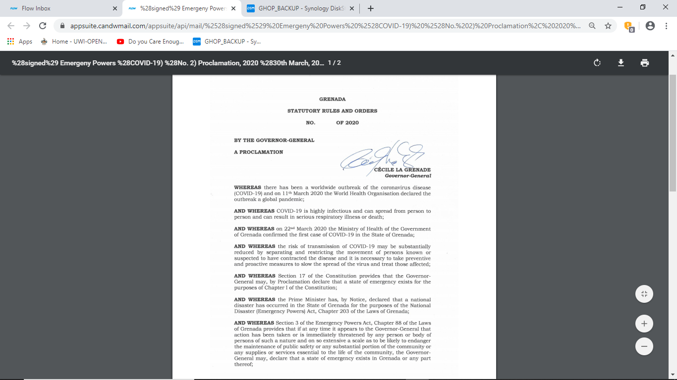

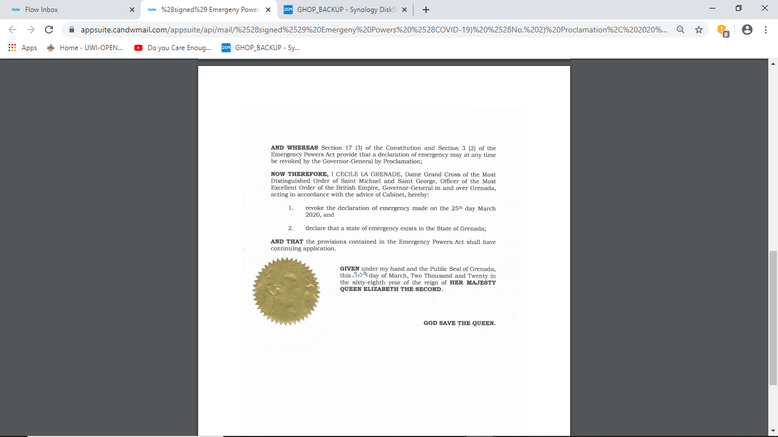

Passed by the House of Representatives this day of 2020.

............………………….………………………

**Clerk to the House of Representatives**